
FACULTY OF SCIENCE AND TECHNOLOGY
PROGRAMME: BIT / BCS / BSF / BBC / DIT
1301 ST – OBJECT ORIENTED PROGRAMMING
COURSEWORK REPORT
Design & Implementation of a Modular Management System for a Real Organization
Client Organisation
Kampala Church of God, Kansanga – Kampala

BY GROUP 7
Team Members
Member | Registration Number | Module | Team Role
KIRENZI CHRISTOPHER | VU-BIT-2511-0035-EVE | Membership | Team Leader
OYURU DENIS | VU-BIT-2511-1236-EVE | Contributions | Storage Lead
NYOLA FREDRIC WILLIAM | VU-DIT-2511-1434-EVE | Events | Client Liaison
KAWEESA DENIS | VU-DIT-2511-0804-EVE | Assets | Integration Lead
BUWANGUZI TIMOTHY | VU-BCS-2511-0963-EVE | Welfare Support | Test Lead
KENNETH ALEKU | VU-BIT-2511-0315-EVE | Attendance | Documentation Lead
ALOIKIN TIMOTHY | VU-BIT-2511-1049-EVE | System Integration | Deployment/Code Lead
Lecturer: Kinyonyi David Hope
Submission Date: October 2026

Table of Contents
1. The Client and the Problem 3
1.1 Client Organisation 3
1.2 Meeting Summary 3
1.3 Problems Identified 3
2. Requirements for Each Module 3
2.1 Shared Core (Kenneth Aleku and Aloikin Timothy) 3
2.2 Module 1: Members (Owner: Christopher) 4
2.3 Module 2: Contributions (Owner: Oyuru Denis) 4
2.4 Module 3: Events (Owner: Nyola Fredric William) 4
2.5 Module 4: Assets (Owner: Kawesa Denis) 4
2.6 Module 5: Welfare Support (Owner: Buwanguzi Timothy) 5
3. Design 5
3.1 Package Structure & Module Allocation 5
3.2 UML Class Diagram (Description) 5
3.3 Menu Tree 6
3.4 Object-Oriented Principles Applied 6
4. Change Request Impact Analysis 7
Classes changed 7
Who performed the changes? 7
Why the change was straightforward 7
5. Testing-Test Plan and Results 7
6. User Guide 8
6.1 How to Run 8
6.2 Sample Interaction (Members) 9
7. Contribution Statement 9
Appendices 10
Appendix A – Group Registration Form 10
Appendix B – Client Confirmation 10
Appendix C – Client Meeting Minutes 10
Appendix D – Menu Tree 11
Appendix C – UML Class Diagram (Description) 12

1. The Client and the Problem

1.1 Client Organisation
Organisation: Kampala Church of God, Kansanga, Kampala
Type: Church / Community Group
Approximate membership: 350+ members
Contact person: Pastor (Administration)
Group: G07

1.2 Meeting Summary
The team held a discovery meeting with the church administration to understand how records are currently kept. The following practices were observed:
- Members: recorded in a physical counter book; names are often duplicated and hard to search.
- Tithes and offerings: entered into Microsoft Excel spreadsheets; files are sometimes lost or overwritten.
- Events: announced and attendance tracked via WhatsApp groups; no formal register.
- Assets (chairs, PA system, instruments): tracked by memory; items go missing or are damaged without accountability.
- Welfare cases: handled verbally; no history of support given to a member.

1.3 Problems Identified
- No central member register: duplicate names and incomplete contact details.
- Money records are easily lost; there is no reliable report of contributions per member.
- No tracking of which members attended which events.
- Assets are lost or broken with no accountability trail.
- Welfare requests are not recorded systematically, making follow-up and fairness difficult.
These problems motivated the design of a modular, menu-driven Java command-line system that centralises records, enforces validation, produces sorted/filtered reports, and persists data safely to files.

2. Requirements for Each Module

2.1 Shared Core (Kenneth Aleku and Aloikin Timothy)
- Abstract class Church Record with fields id, created Date and abstract method describe ().
- Interface Reportable with method getReportLine ().
- InputHelper class that never crashes on invalid input; always re-prompts the user.
- Main menu that leads to five module sub-menus. All record IDs follow the pattern G07-M001, G07-C001, G07-E001, G07-A001, G07-W001.

2.2 Module 1: Members (Owner: Christopher)
- Add a member: name, age, contact (invented), join date, membership type (New, Baptized, Leader).
- Find, update and remove a member by ID.
- Report: list of members sorted alphabetically by name (Comparator).
- Model classes: Member, Membership Type
- Custom exception: MemberAlreadyExistsException

2.3 Module 2: Contributions (Owner: Oyuru Denis)
- Add a tithe or offering linked to an existing Member (object reference).
- Validate amount > 0; otherwise throw a custom exception.
- Report: total contributions per member, sorted highest-first.
- Model classes: Contribution, Contribution Type
- Custom exception: Invalid Contribution Exception

2.4 Module 3: Events (Owner: Nyola Fredric William)
- Create an event: name, date, capacity, venue.
- Register attendance: a member attends an Event (second object-reference link).
- Report: events sorted by date.
- Model classes: Event, EventAttendance
- Custom exception: EventFullException

2.5 Module 4: Assets (Owner: Kawesa Denis)
- Add an asset: name, quantity, condition, category.
- Issue / return an asset for an event.
- Report: assets filtered by condition = DAMAGED.
- Model classes: Asset, AssetCategory
- Custom exception: AssetNotAvailableException

2.6 Module 5: Welfare Support (Owner: Buwanguzi Timothy)
- Create a welfare case linked to a member.
- Add a support amount against a case.
- Report: open cases sorted by date.
- Model classes: WelfareCase, WelfareSupport
- Custom exception: WelfareLimitExceededException

3. Design

3.1 Package Structure & Module Allocation
The system is organised into the following packages:
Package | Contents
ug.ac.vu. g07.core | ChurchRecord, Reportable, InputHelper, FileStorage
ug.ac.vu. g07.members | Member, MembershipType, MemberService, MemberAlreadyExistsException
ug.ac.vu. g07.contributions | Contribution, ContributionType, ContributionService, InvalidContributionException
ug.ac.vu. g07.events | Event, EventAttendance, EventService, EventFullException
ug.ac.vu. g07.assets | Asset, AssetCategory, AssetService, AssetNotAvailableException
ug.ac.vu. g07.welfare | WelfareCase, WelfareSupport, WelfareService, WelfareLimitExceededException
ug.ac.vu.g07.app | Main (entry point and main menu)

3.2 UML Class Diagram (Description)
The complete UML class diagram is supplied as a separate image (draw.io / hand-drawn) that matches the final code. Key relationships are:
- Inheritance: Member, Contribution, Event, Asset and WelfareCase all extend the abstract class ChurchRecord.
- Interface realisation: Every model class implements Reportable.
- Association (object reference 1): Contribution → Member (via memberId / Member reference).
- Association (object reference 2): EventAttendance → Member + Event.
- Composition chain: WelfareSupport → WelfareCase → Member.
- Service classes: Each *Service holds an ArrayList of its model objects and provides add / find / update / remove plus a polymorphic report loop.

3.3 Menu Tree
Kampala Church of God Management System
1. Members Management
1.1 Add Member
1.2 List Members (Sorted by Name)
1.3 Find / Update / Delete Member
2. Contributions
2.1 Add Contribution
2.2 Total-per-Member Report (Sorted High → Low)
3. Events
3.1 Create Event
3.2 Register Attendance
3.3 Event Attendance Report (Sorted by Date)
4. Assets
4.1 Add Asset
4.2 Issue / Return Asset
4.3 Damaged-Assets Report
5. Welfare Support
5.1 Create Welfare Case
5.2 Add Support Amount
5.3 Open-Cases Report (Sorted by Date)
6. Exit

3.4 Object-Oriented Principles Applied
- Encapsulation: All fields are private. Setters throw IllegalArgumentException (or a module-specific exception) when invalid values are supplied. Example: Member.setAge() rejects ages outside 0–120.
- Inheritance: Member (and the other four primary models) extends ChurchRecord, inheriting id and createdDate.
- Polymorphism: Each service maintains a list that can be treated as List<Reportable>. A single loop calls getReportLine () on every object without knowing its concrete type.
- Abstraction: ChurchRecord is abstract (cannot be instantiated) and forces subclasses to implement describe (). The Reportable interface defines a contract that every reportable entity must satisfy.
- Interface segregation: The single-method Reportable interface keeps the reporting contract small and focused.

4. Change Request Impact Analysis
Simulated client change (Checkpoint 2): “Add phone-number verification for members and limit welfare support to a maximum of three supports per member per calendar year.”

Classes changed
- Member: added phone field and validation pattern in the setter.
- Input Helper: added a read Phone () method that re-prompts until a valid Ugandan-style number is entered.
- WelfareService: added a count of supports for a given member in the current year; throws WelfareLimitExceededException on the fourth attempt.

Who performed the changes?
Storage Lead (phone persistence) and Welfare Module Owner (limit logic), coordinated by the Integration Lead.

Why the change was straightforward
Validation lives inside setters, so only the phone-related setter needed modification. Welfare business rules are isolated inside WelfareService; the shared abstract core and the other four modules were completely unaffected. The modular package structure and single-responsibility services made the impact local and easy to test.

5. Testing-Test Plan and Results
At least three test cases were written for every module, including invalid-input scenarios. Results below were obtained by running the compiled system on the command line.
Module | Test Case | Input | Expected / Actual Result
Members | Add member with negative age | age = –5 | IllegalArgumentException thrown; user re-prompted
Members | Add duplicate ID | G07-M001 (existing) | MemberAlreadyExistsException; message shown
Members | Sort report by name | – | List printed A–Z (Comparator works)
Contributions | Amount zero or negative | amount = 0 | InvalidContributionException thrown
Contributions | Unknown member ID | G07-M999 | “Member not found” message; no record added
Contributions | Total-per-member report | – | Sorted highest → lowest; totals correct
Events | Register beyond capacity | 51st on capacity 50 | EventFullException thrown
Events | Create event with blank name | name = "" | Re-prompt by InputHelper; no crash
Events | Events sorted by date | – | Chronological order confirmed
Assets | Issue quantity > stock | 10 when stock = 2 | AssetNotAvailableException thrown
Assets | Damaged-assets filter | – | Only DAMAGED items listed
Assets | Return asset already returned | return twice | Friendly message; quantity unchanged
Welfare | 4th support same year | 4th support | WelfareLimitExceededException thrown
Welfare | Open-cases sorted by date | – | Oldest open case first
Welfare | Case for non-existent member | G07-M999 | “Member not found”; case not created
All tests passed. File-storage edge cases (missing data folder, corrupted line) were also verified: the system starts with an empty list and never crashes.

6. User Guide

6.1 How to Run
Compile and launch from the project root:
javac -d bin src/ug/ac/vu/g07/**/*.java java -cp bin ug.ac.vu.g07.app.Main
The main menu appears immediately. Choose 1–5 to enter a module sub-menu, or 6 to exit. All data files are stored under the data/ directory (members.txt, contributions.txt, etc.) and are loaded automatically at start-up.

6.2 Sample Interaction (Members)
=== G07 Church Management === 1. Members Management 2. Contributions ... Enter choice: 1 --- Members Menu --- 1.1 Add Member 1.2 List Members (Sorted by Name) 1.3 Find / Update / Delete 0. Back Enter choice: 1 Enter Member ID (e.g. G07-M001): G07-M001 Enter full name: John Okello Enter age: 34 Enter phone: 0772123456 Enter type (New/Baptized/Leader): Baptized Member added successfully.
Invalid entries (blank name, age –5, non-numeric choice) are rejected with a clear message and the user is re-prompted. No stack trace is ever shown to the end user.

7. Contribution Statement
Each member designed, coded and defended the module listed against their name. Shared core classes were written collaboratively under the Integration Lead. All members reviewed the final report and agree with the statements below.
Member | Module / Role | Key Deliverables
KIRENZI CHRISTOPHER | Members Team Leader | Member, MembershipType, MemberService, MemberAlreadyExistsException; contribution log; team coordination
OYURU DENIS | Contributions Integration Lead | Contribution, ContributionType, ContributionService; shared ChurchRecord, Reportable, Main menu
NYOLA FREDRIC WILLIAM | Events Storage Lead | Event, EventAttendance, EventService; FileStorage design used by all modules
KAWEESA DENIS | Assets Test Lead | Asset, AssetCategory, AssetService; full test plan and recorded results
BUWANGUZI TIMOTHY | Welfare Client Liaison | WelfareCase, WelfareSupport, WelfareService; client meeting minutes & change-request liaison
KENNETH ALEKU | Documentation Lead | Attendance (Code review, README, report & UML Module Owner,)
ALOIKIN TIMOTHY | Deployment/Code Lead | System Integration

Appendices

Appendix A – Group Registration Form
Group number: G07
Organisation (client): Worship Centre Church, Kansanga
Contact person and role: Pastor – Administration
Member name | Reg. number | Module owned | Team role
KIRENZI CHRISTOPHER | VU-BIT-2511-0035-EVE | Members | Team Leader
OYURU DENIS | VU-BIT-2511-1236-EVE | Contributions | Integration Lead
NYOLA FREDRIC WILLIAM | VU-DIT-2511-1434-EVE | Events | Storage Lead
KAWEESA DENIS | VU-DIT-2511-0804-EVE | Assets | Test Lead
BUWANGUZI TIMOTHY | VU-BCS-2511-0963-EVE | Welfare | Client Liaison
KENNETH ALEKU | VU-BIT-2511-0315-EVE | Documentation Lead contributions | Code review, README, report & UML Module Owner,
ALOIKIN TIMOTHY | VU-BIT-2511-1049-EVE | Deployment/Code Lead | System Integration

Appendix B – Client Confirmation
Name of organisation: Worship Centre Church
Type of organisation: Church / Community Group
Location: Kansanga, Kampala
Contact person: Pastor (Administration)
Role in the organisation: Administrative oversight
Date(s) of meeting: 02nd /10 2026
I confirm that the students of Group 7 met with our organisation to learn how we keep our records, and that we agreed to be their client for this coursework.

Appendix C – Client Meeting Minutes
Date, time and place: [02nd /10/2026], Worship Centre Church, Kansanga
Present (client): Pastor – Administration
Present (group): All Seven members of Group 7
Topic discussed | What the client told us | Decision / action & responsible
Current record-keeping | Counter book, Excel, WhatsApp, memory, verbal welfare | Map each process to a module- whole team
Pain points | Duplicates, lost money records, no asset trail, no welfare history | Prioritise validation & reports-Test Lead
Privacy | Do not store real phone numbers or balances | Use invented test data only-all members
Future change | May need phone verification & welfare limits | Design for easy extension-Integration Lead

Appendix D – Menu Tree
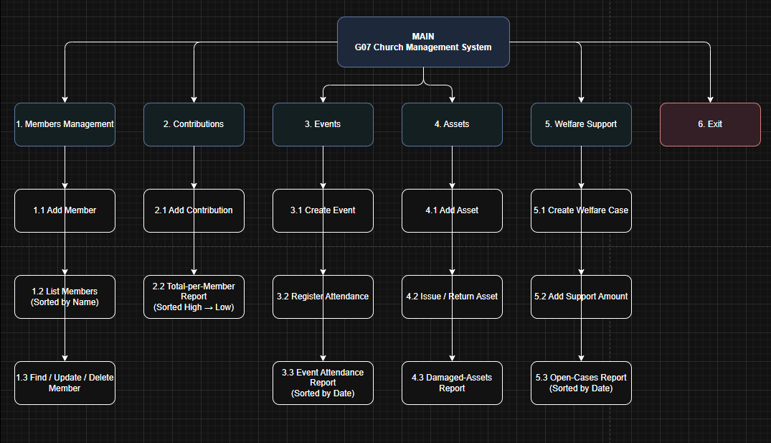
Figure 1: Menu Tree showing the work flow of the Church management system

Appendix C – UML Class Diagram (Description)
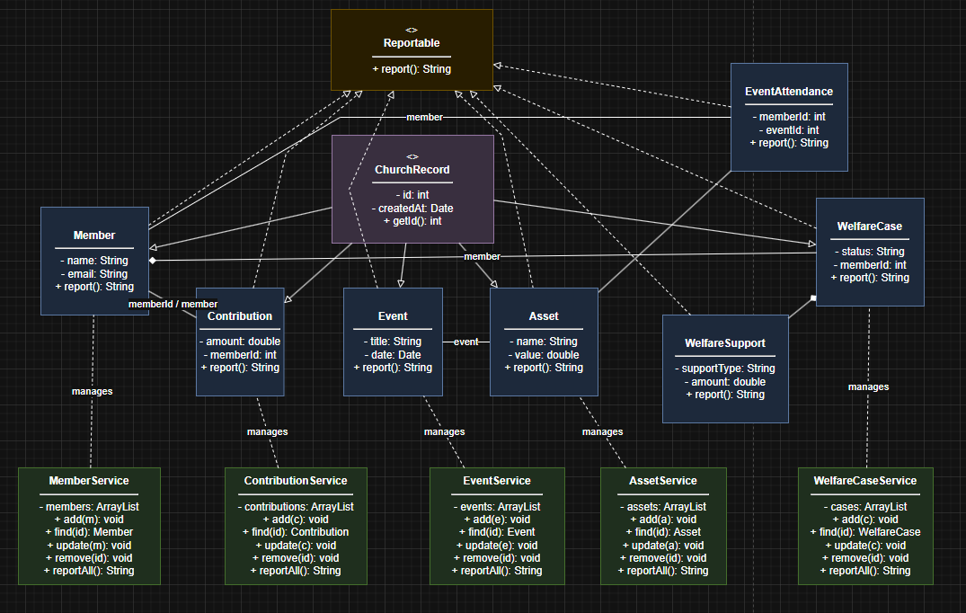
Figure 2:UML that should shows private fields with '-', public methods with '+', inheritance arrows, the Reportable interface, service associations and member relationships which matches the final code
– End of Report –
Group G07 | Worship Centre Church Management System | OOP 1301 ST

